**Assignment 8 PF theory**

**Question#01**

**Write a program using structure that comprises of structure members as student ID, Student Name, Student GPA and Student percentage and we have to save the record of two students in two different structure variables. Pass this data of two students to a UDF and UDF prints the data for two students.**

**Source code**

#include<iostream>

using namespace std;

struct sdf

{

string name;

int id=0;

int percentage=0;

int gpa=0;

};

struct sds

{

string name2;

int id2=0;

int percentage2=0;

int gpa2=0;

};

int print(sdf stdata1, sds stdata2)

{

cout<<"Name of first student: "<<stdata1.name<<endl;

cout<<"Id of first student: "<<stdata1.id<<endl;

cout<<"Percentage of first student: "<<stdata1.percentage<<endl;

cout<<"GPA of first student: "<<stdata1.gpa<<endl;

cout<<"Name of second student: "<<stdata2.name2<<endl;

cout<<"Id of second student: "<<stdata2.id2<<endl;

cout<<"Percentage of second student: "<<stdata2.percentage2<<endl;

cout<<"GPA of second student: "<<stdata2.gpa2<<endl;

return 0;

}

int main ()

{

sdf stdata1;

sds stdata2;

cout<<"Enter name of first student: "<<endl;

cin>>stdata1.name;

cout<<"Enter id of first student: "<<endl;

cin>>stdata1.id;

cout<<"Enter Percentage of first student: "<<endl;

cin>>stdata1.percentage;

cout<<"Enter GPA of first student: "<<endl;

cin>>stdata1.gpa;

cout<<"Enter name of second student: "<<endl;

cin>>stdata2.name2;

cout<<"Enter id of second student: "<<endl;

cin>>stdata2.id2;

cout<<"Enter Percentage of second student: "<<endl;

cin>>stdata2.percentage2;

cout<<"Enter GPA of second student: "<<endl;

cin>>stdata2.gpa2;

print(stdata1, stdata2);

return 0;

}

**Output**

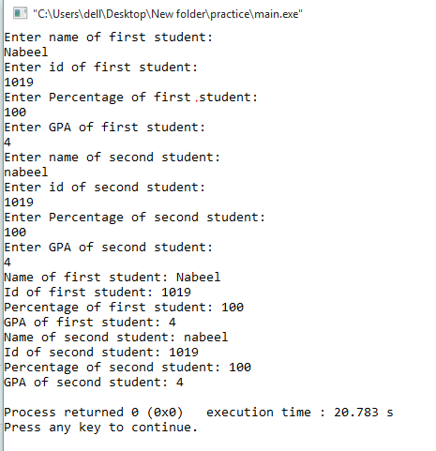

**Write a program that takes record of a student input in UDF in structure members as student ID, Student Name, Student GPA, Student percentage and students 5 marks in members of array. The UDF calculates the total of students marks and returns this total to main function and main function prints it.**

**SOURCE CODE**

**#include<iostream>**

**using namespace std;**

**struct stdata**

**{**

**string name;**

**int id;**

**int gpa;**

**int percentage;**

**};**

**int calculator (stdata stdata1)**

**{**

**int subjectmarks[5];**

**int total=0;**

**cout<<"Enter name: "<<endl;**

**cin>>stdata1.name;**

**cout<<"Enter id: "<<endl;**

**cin>>stdata1.id;**

**cout<<"Enter GPA: "<<endl;**

**cin>>stdata1.gpa;**

**cout<<"Enter marks of 5 subjects: "<<endl;**

**for(int i=0; i<=4; i++)**

**{**

**cin>>subjectmarks[i];**

**total = total + subjectmarks[i];**

**}**

**stdata1.percentage = total*0.5;**

**cout<<"The name of the student is: "<<stdata1.name<<endl;**

**cout<<"The roll no of the student is: "<<stdata1.id<<endl;**

**cout<<"The total marks of the student is: "<<stdata1.gpa<<endl;**

**cout<<"The total marks of the student is: "<<stdata1.percentage<<endl;**

**return(stdata1.name, stdata1.id,stdata1.gpa,stdata1.percentage );**

**}**

**int main()**

**{**

**stdata stdata1;**

**calculator(stdata1);**

**cout<<"The name of the student is: "<<stdata1.name<<endl;**

**cout<<"The roll no of the student is: "<<stdata1.id<<endl;**

**cout<<"The total marks of the student is: "<<stdata1.gpa<<endl;**

**cout<<"The total marks of the student is: "<<stdata1.percentage<<endl;**

**}**

**OUTPUT**

